Christopher Bazyani

CYB 552

Advanced Hacking Prevention

Lab 2

Applying Encryption and Hashing Algorithms for Secure Communications

**Section 1: Hands-On Demonstration**

Part 1: Create a Text File on Linux

From the Linux toolbar, click the Applications menu, then navigate to Accessories > gedit Text Editor to open the gedit text editor

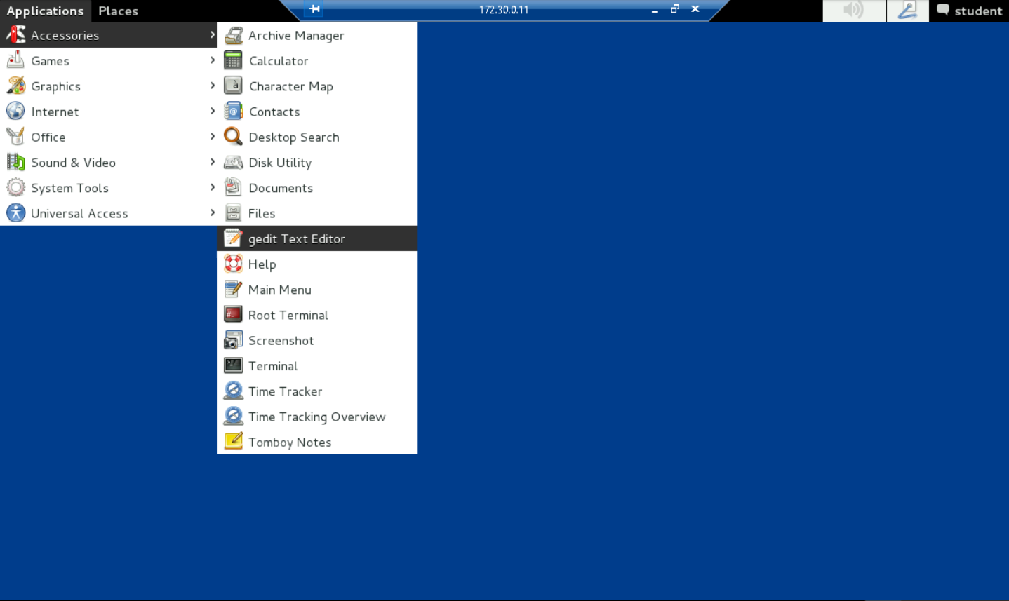

In the gedit window, type This is an example., then click the Save button on the gedit toolbar to open the Save As dialog box

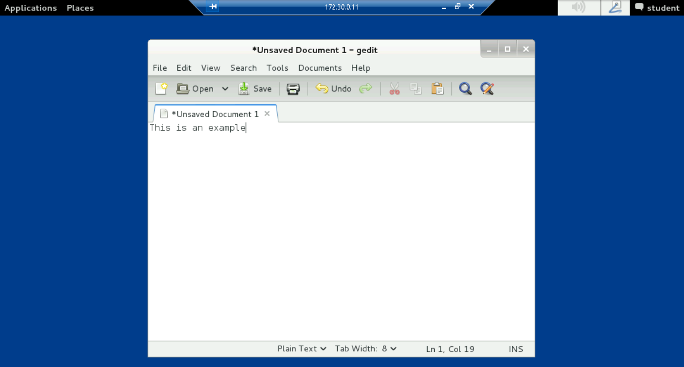

In the Save As dialog box, navigate to the Documents folder (student > Documents), then type Example.txt in the Name box and click Save to save the file

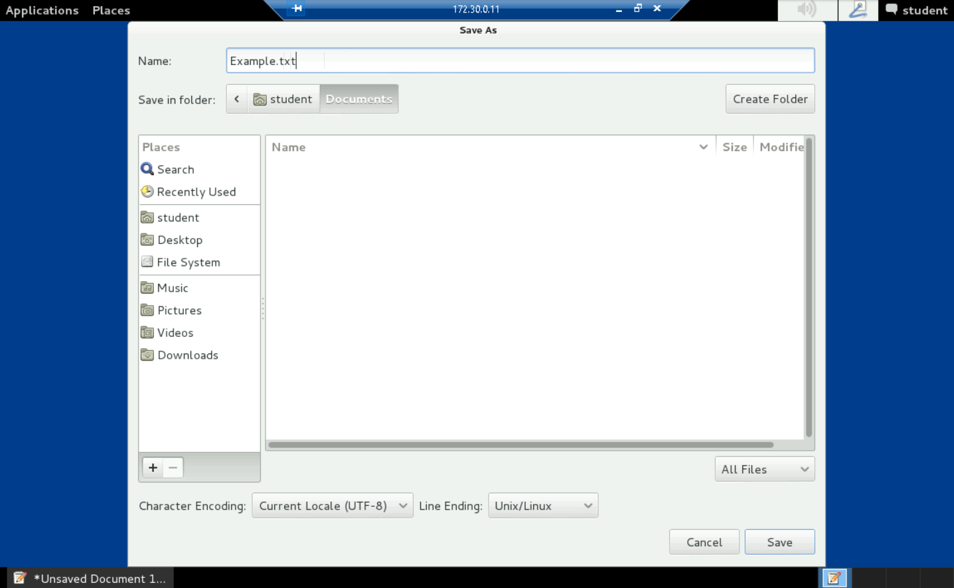

Part 2: Create a MD5sum and a SHA1sum hash string

From the Linux toolbar, click the Applications menu, then navigate to Accessories > Terminal to open a terminal window

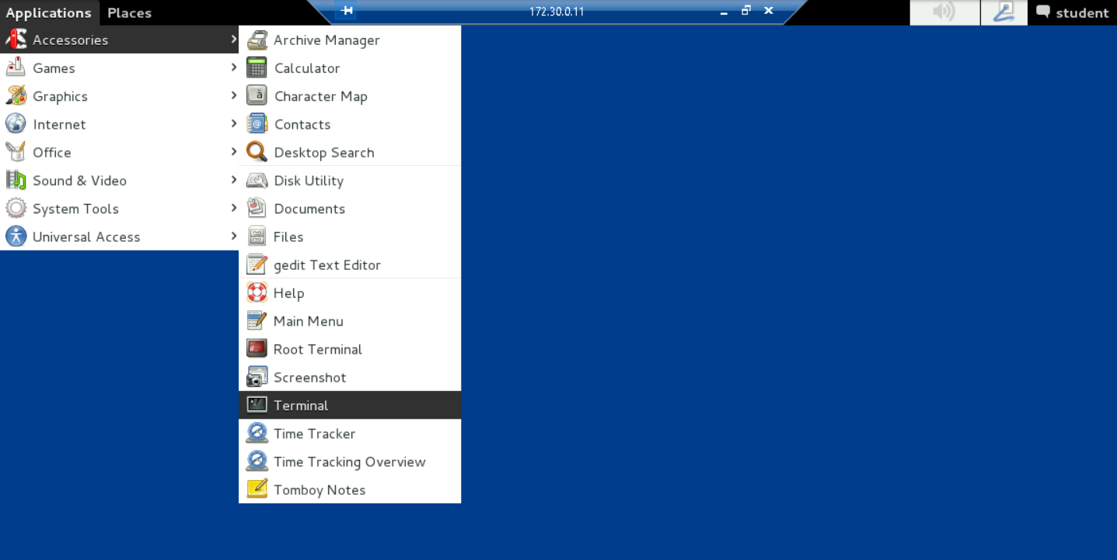

At the command prompt, type md5sum --help and press Enter to open the md5 help document, then review the process and options for this tool

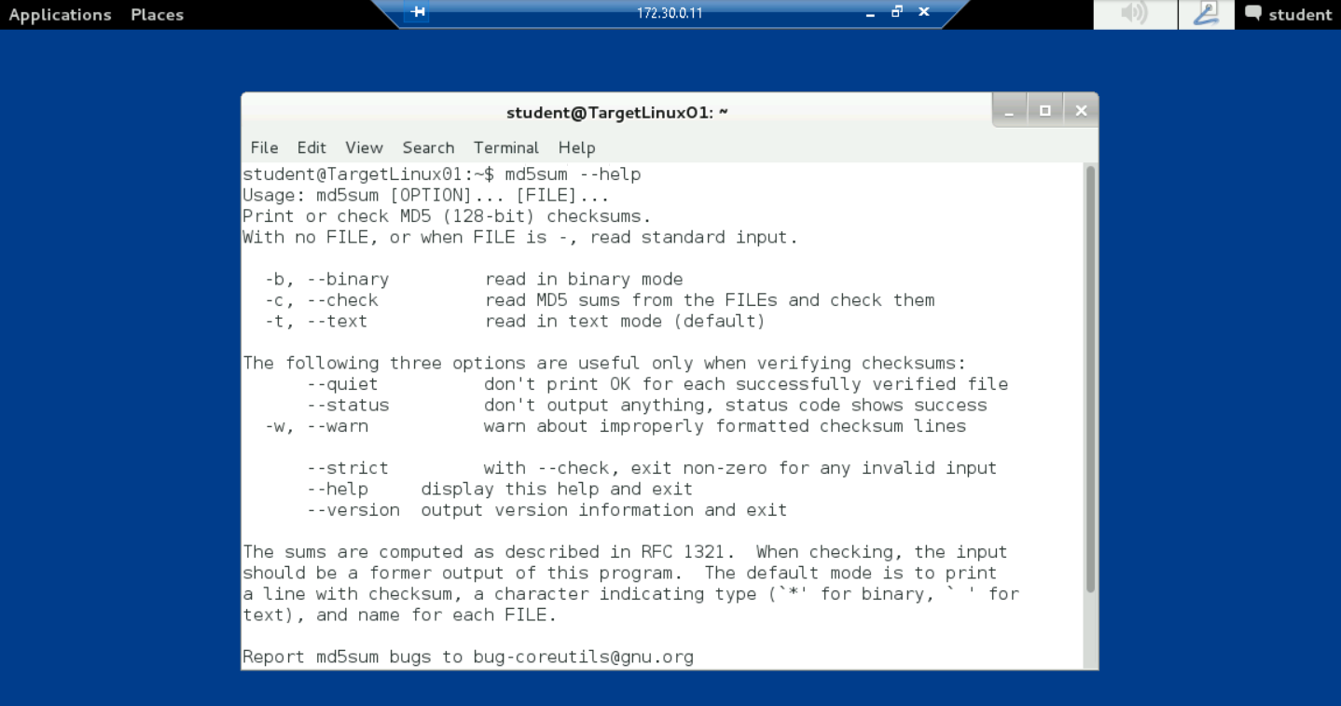

At the command prompt, type cd Documents and press Enter to change the current directory to the Documents folder

At the command prompt, type ls -l and press Enter to list the files in the Documents folder

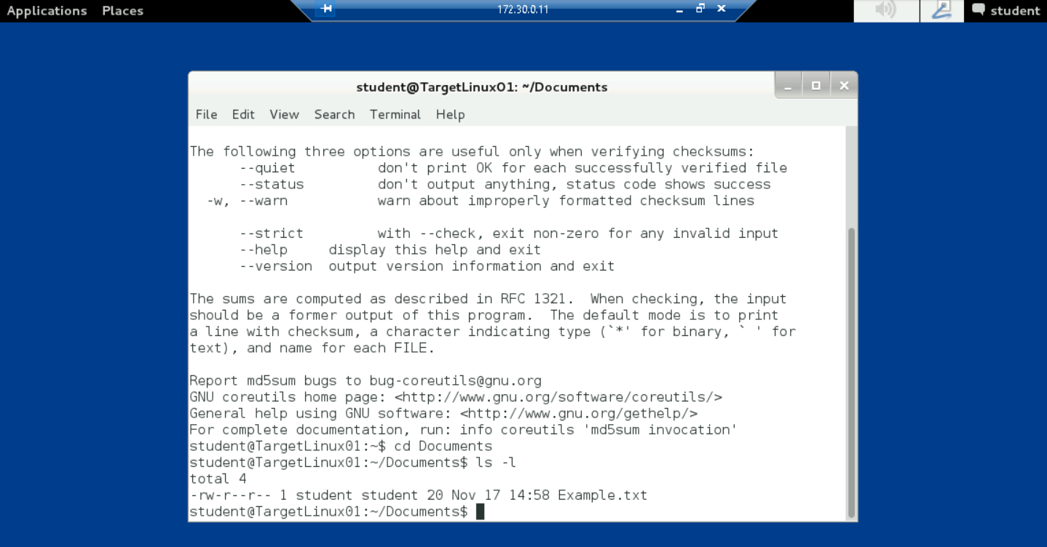

At the command prompt, type cat Example.txt and press Enter to view the contents of the Example.txt file that you created earlier

The contents of the file should be: This is an example

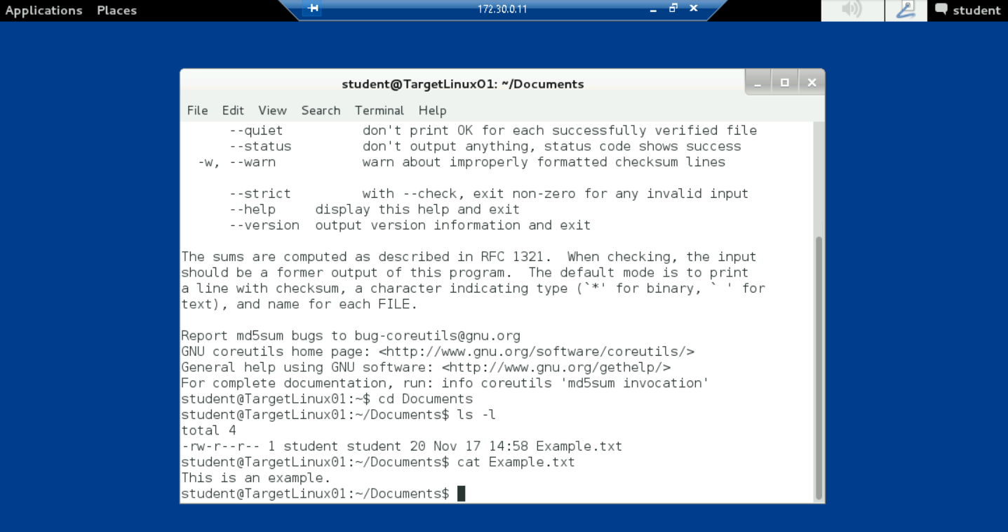

At the command prompt, type md5sum Example.txt and press Enter to create an MD5sum hash string for the Example.txt file

The tool will return a string of hexadecimal numbers that will be unique to your file on your virtual session

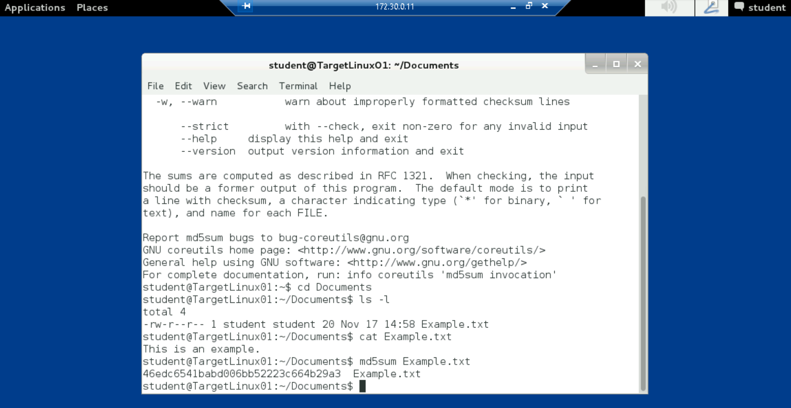

At the command prompt, type md5sum Example.txt > Example.txt.md5 and press Enter to store the MD5sum hash string for the Example.txt file in a new file

At the command prompt, type ls and press Enter to list the files in the student folder and verify that the new Example.txt.md5 file has been added to the Documents folder

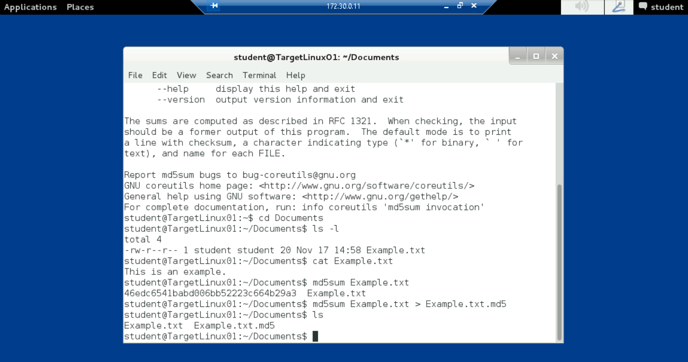

At the command prompt, type cat Example.txt.md5 and press Enter to view the contents of the Example.txt.md5 file

The contents of the file should be the same MD5sum hash string that you recorded in step 7

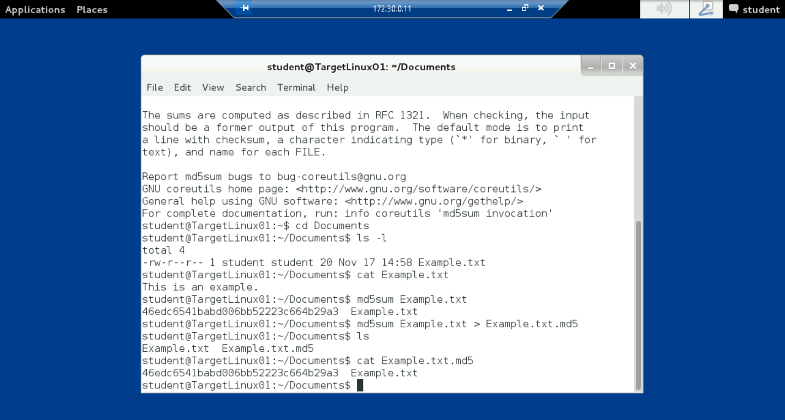

At the command prompt, type md5sum -c Example.txt.md5 and press Enter to check the MD5sum hash created for the Example.txt file

If the file has not been modified, the system will display the words Example.txt: OK, indicating that the MD5sum hash is the same for both

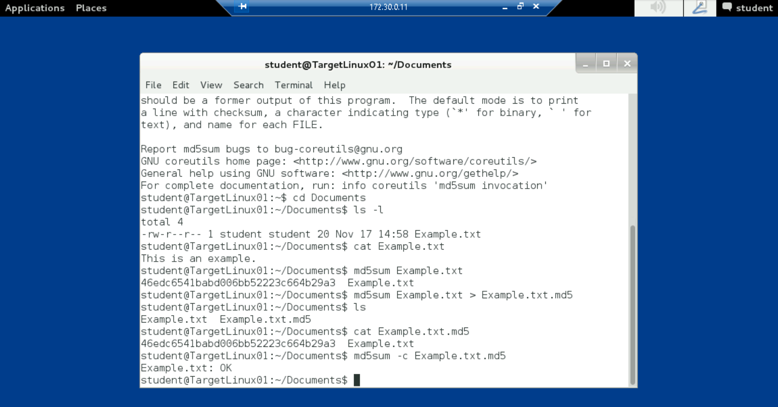

At the command prompt, type sha1sum --help and press Enter to open the sha1sum help document, then review the features and switches for this tool

At the command prompt, type sha1sum Example.txt and press Enter to create a SHA1sum hash string for the Example.txt file

The tool will return a string of hexadecimal numbers that will be unique to your file on your virtual session

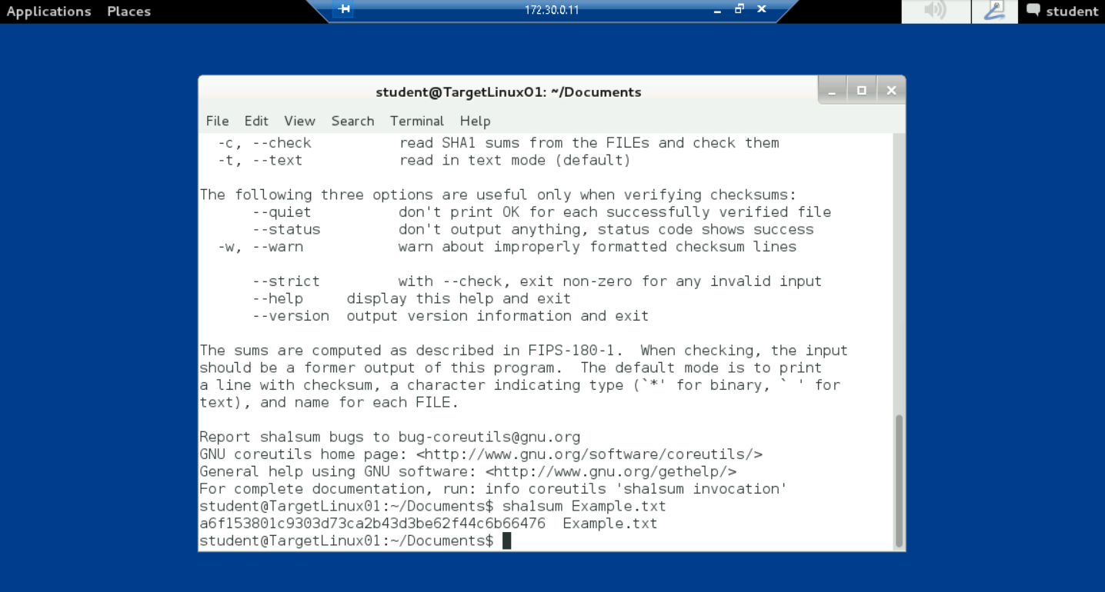

At the command prompt, type sha1sum Example.txt > Example.txt.sha1 and press Enter to store the SHA1sum hash string for the Example.txt file in a new file

At the command prompt, type ls and press Enter to list the files in the student folder and verify that the new Example.txt.sha1 file has been added to the Documents folder

At the command prompt, type cat Example.txt.sha1 and press Enter to view the contents of the Example.txt.sha1 file

The contents of the file should be the same SHA1sum hash string that you recorded in step 15

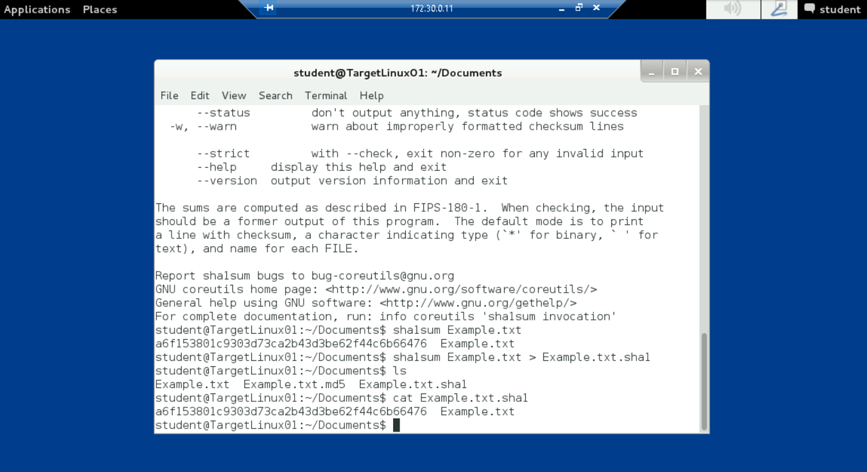

At the command prompt, type sha1sum -c Example.txt.sha1 and press Enter to check the SHA1sum hash created for the Example.txt file

If the file has not been modified, the system will display the words Example.txt: OK, indicating that the SHA1sum hash is the same for both

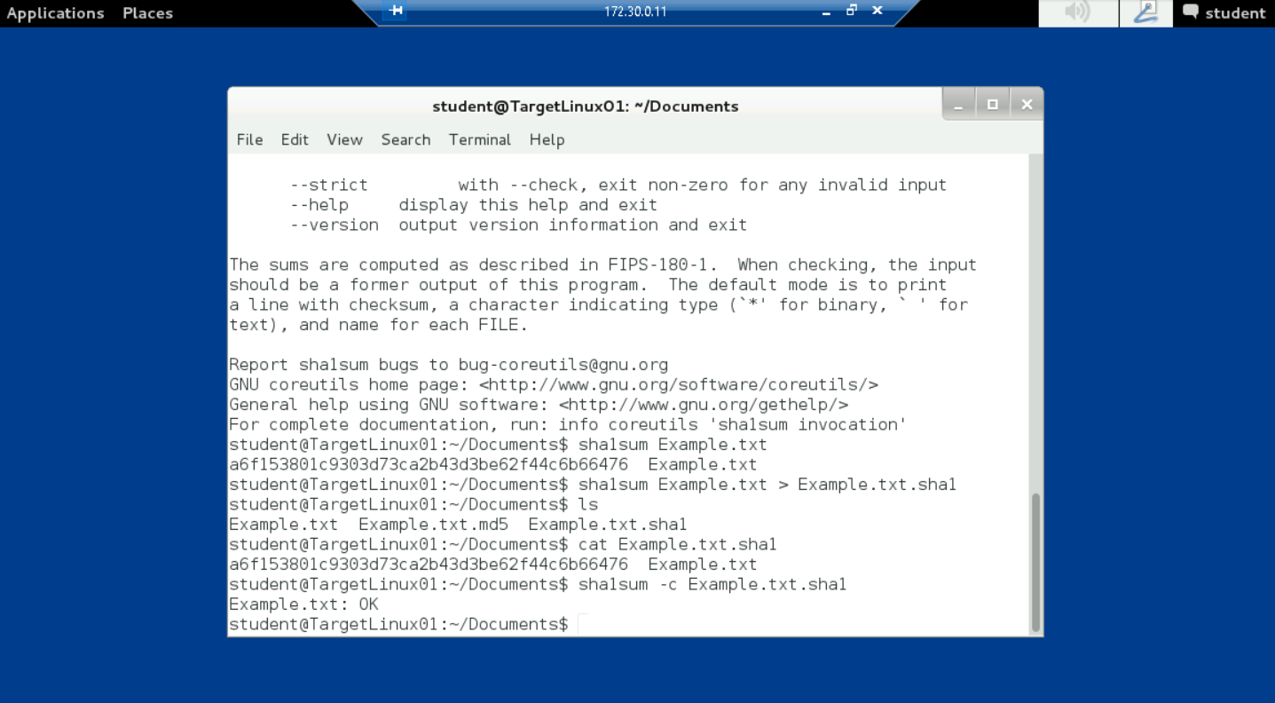

Part 3: Modify a File and Verify Hash Values

At the command prompt, type echo yourname >> Example.txt, replacing yourname with your own name, and press Enter to add your own name to the end of the Example.txt file, modifying its contents

At the command prompt, type cat Example.txt and press Enter to view the contents of the modified file

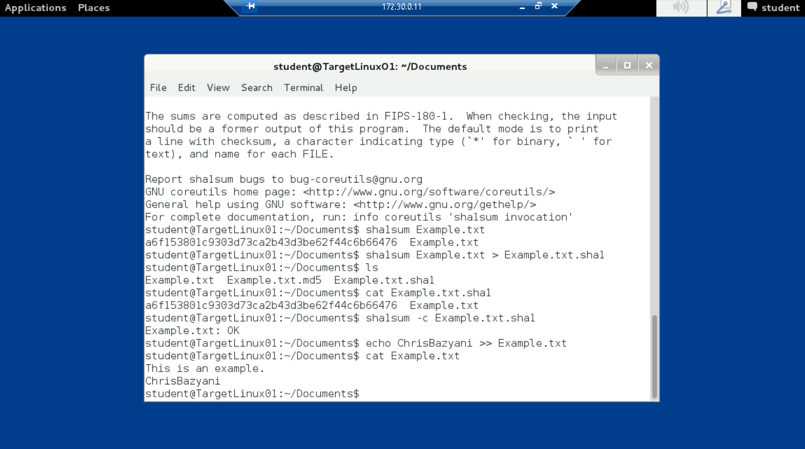

At the command prompt, type md5sum Example.txt and press Enter to create an MD5sum hash string for the modified Example.txt file

The tool will return a string of hexadecimal numbers that does not match the string from the original Example.txt file

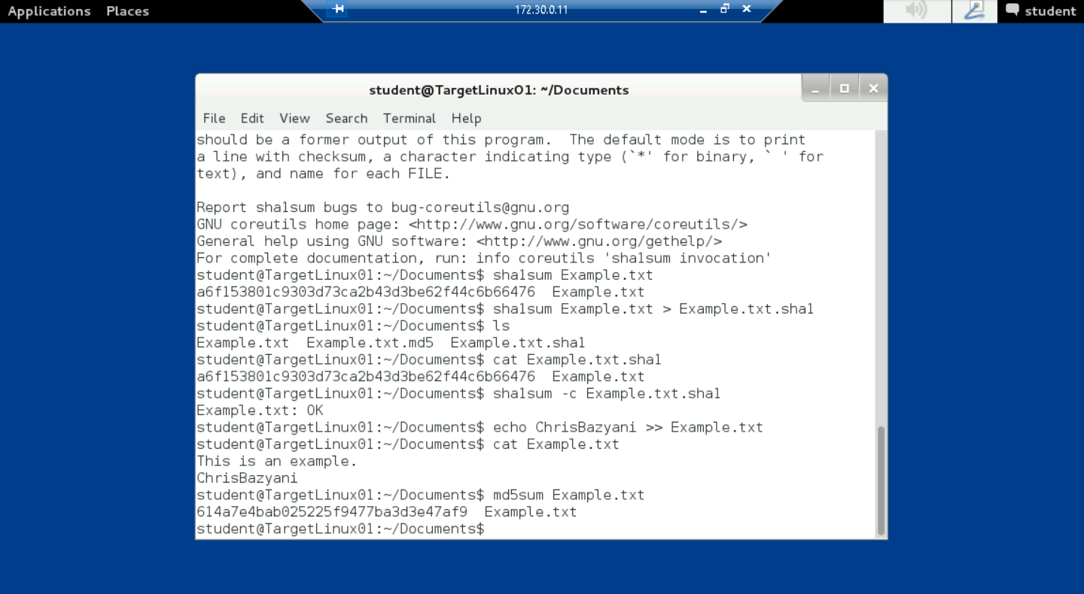

At the command prompt, type sha1sum Example.txt and press Enter to create an SHA1sum hash string for the modified Example.txt file

The tool will return a string of hexadecimal numbers

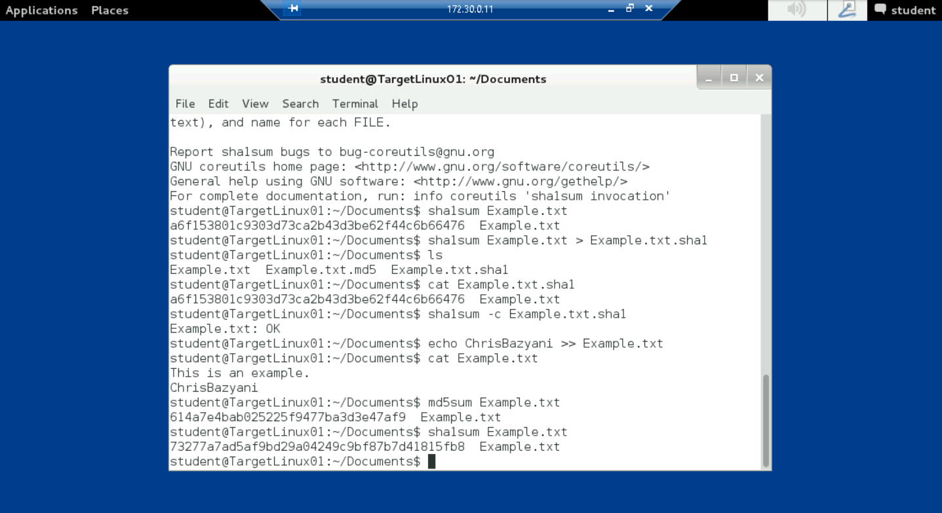

Part 4: Generate GnuPG Keys

In the terminal window, verify that the command prompt is student@TargetLinux01:~/Documents$, indicating that student is the logged on user

At the command prompt, type gpg --gen-key and press Enter to initiate the process for generating a public encryption key

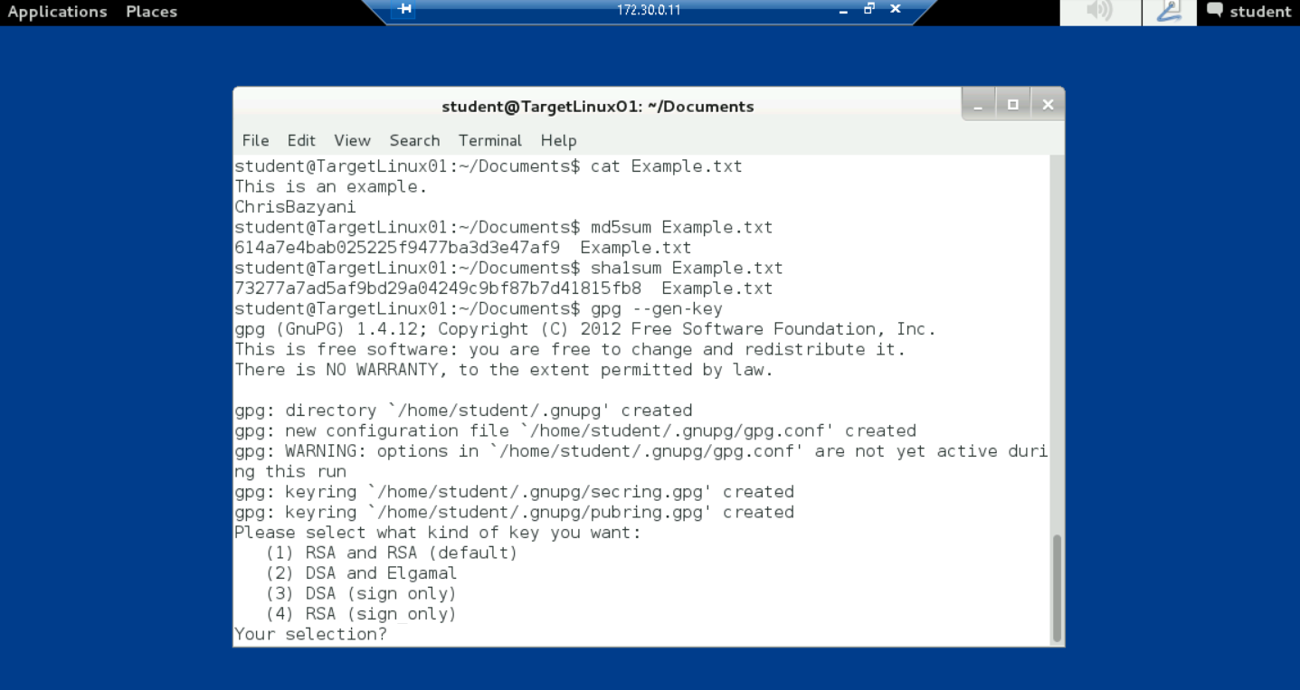

When prompted by the key generator, type the following answers in response to the onscreen questions. Press Enter after each entry

Your [key type] selection? 1 (RSA and RSA (default)

What keysize do you want? 1024 (1024 bit length)

Key is valid for? 0 (Key does not expire at all)

Is this correct? y (yes)

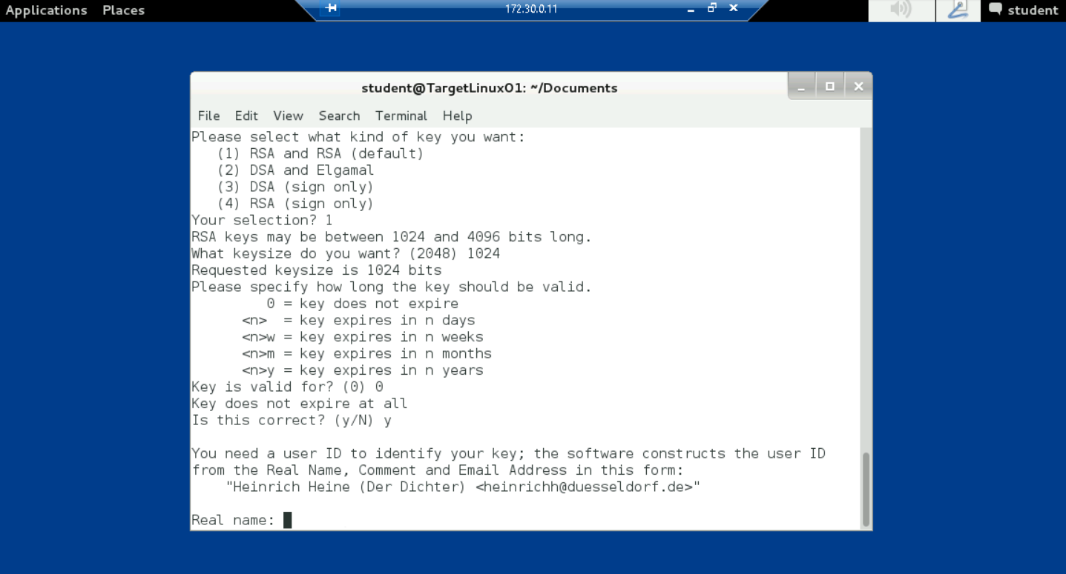

When prompted by the key generator, type the following answers in response to the request for a user ID to identify your key. Press Enter after each entry

The system will display an error message: Not enough random bytes available. You can generate entropy (random bytes) by performing a series of actions, such as typing on the keyboard, moving the mouse, using disk space, playing games, or running a script, as you will in the following steps

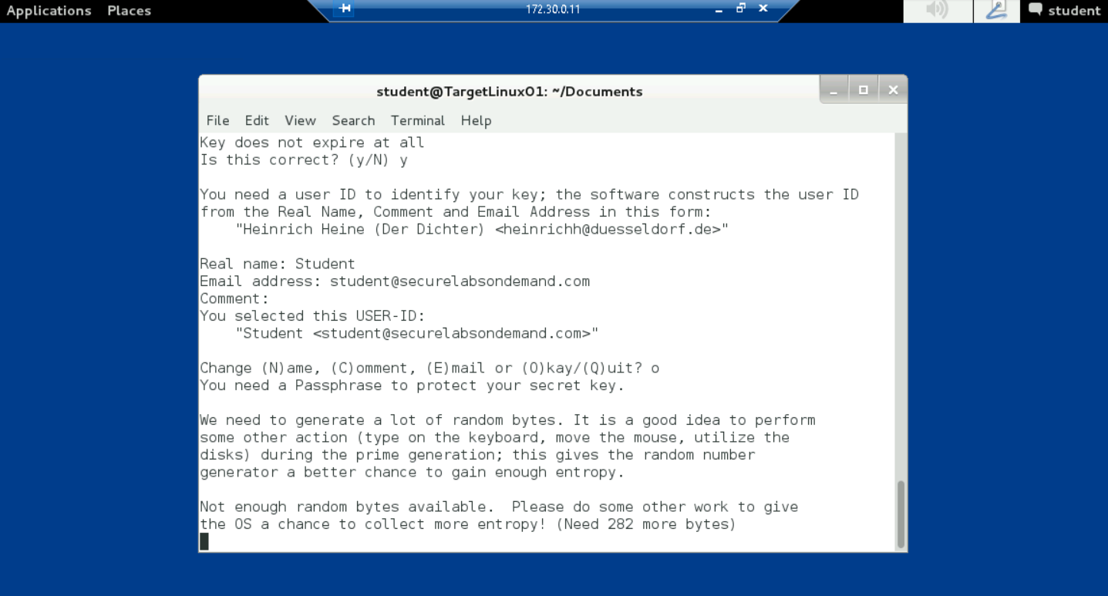

From the Linux toolbar, click the Applications menu, then navigate to Accessories > Terminal to open a second terminal window

At the command prompt, type ./entropy_loop.sh and press Enter to run a script that will “keep the machine busy” while it generates a key pair

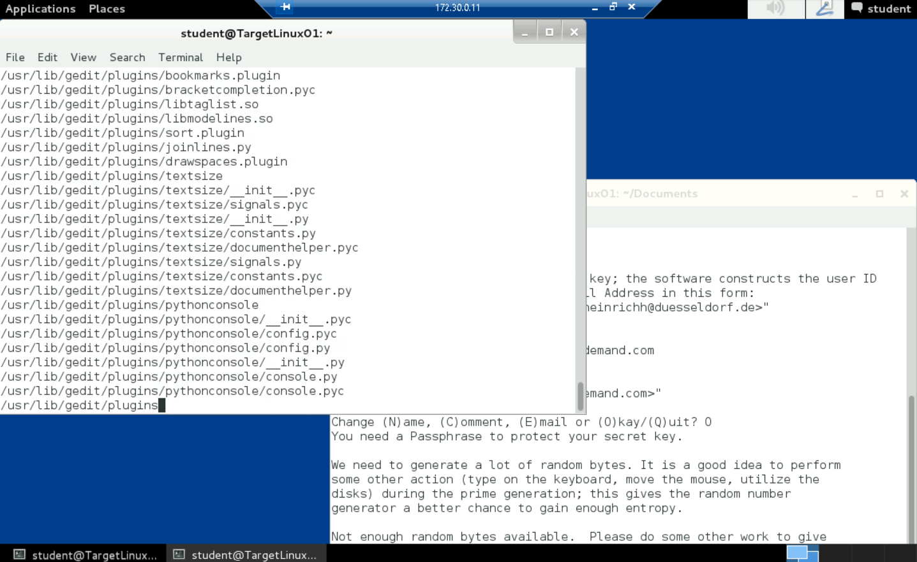

When the command prompt returns in the first terminal window, close the second terminal window

At the command prompt in the original window, type gpg --export -a > student.pub and press Enter to save the GnuPG key to a new file called student.pub

At the command prompt, type pwd and press Enter to determine which Linux working directory (wd) you are currently using

The system should display /home/student/Documents, indicating that you are in the student’s Documents folder. If you see something else on your display, change to that directory before continuing

At the command prompt, type ls and press Enter to list the files in the folder and verify that the student.pub file was saved to the correct user account and location

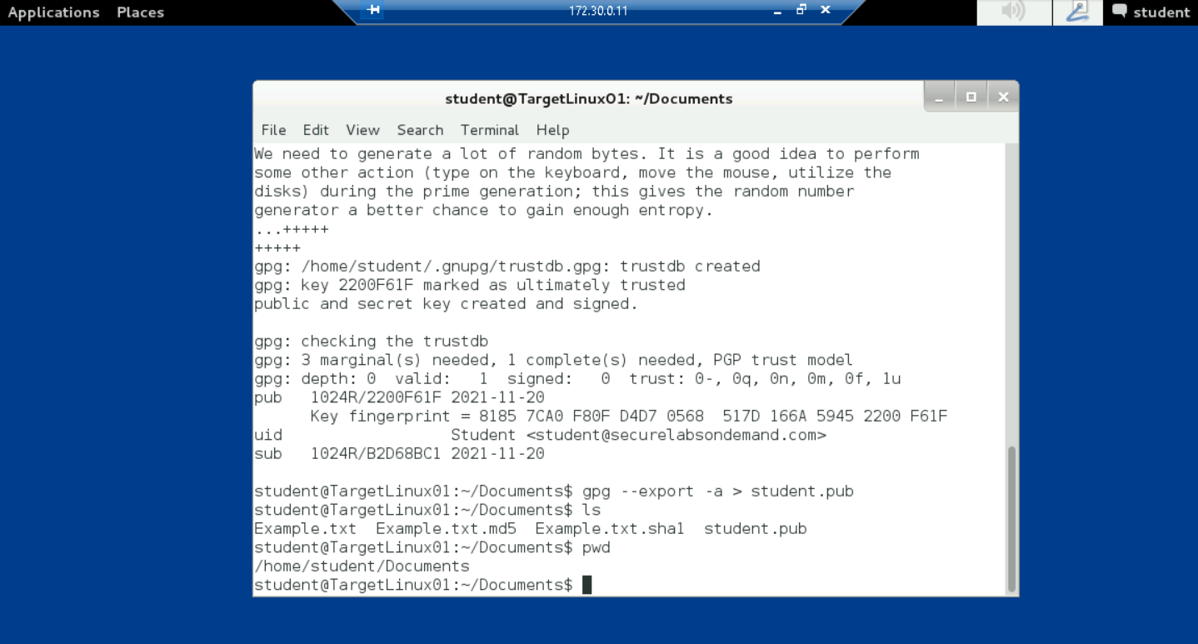

At the command prompt, type su Instructor and press Enter to switch to the Instructor account

When prompted for a password, type instructor and press Enter

At the command prompt, type cd /home/Instructor and press Enter to change directories to the Instructor folder

At the command prompt, type ls and press Enter to list the contents of the Instructor folder

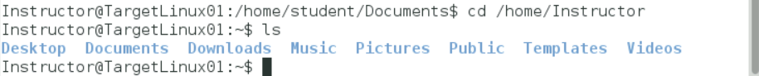

Repeat steps 2-9 to create the GnuPG keys for the Instructor account. Note the following change to step 4

Real name: Instructor

Email address: instructor@securelabsondemand.com

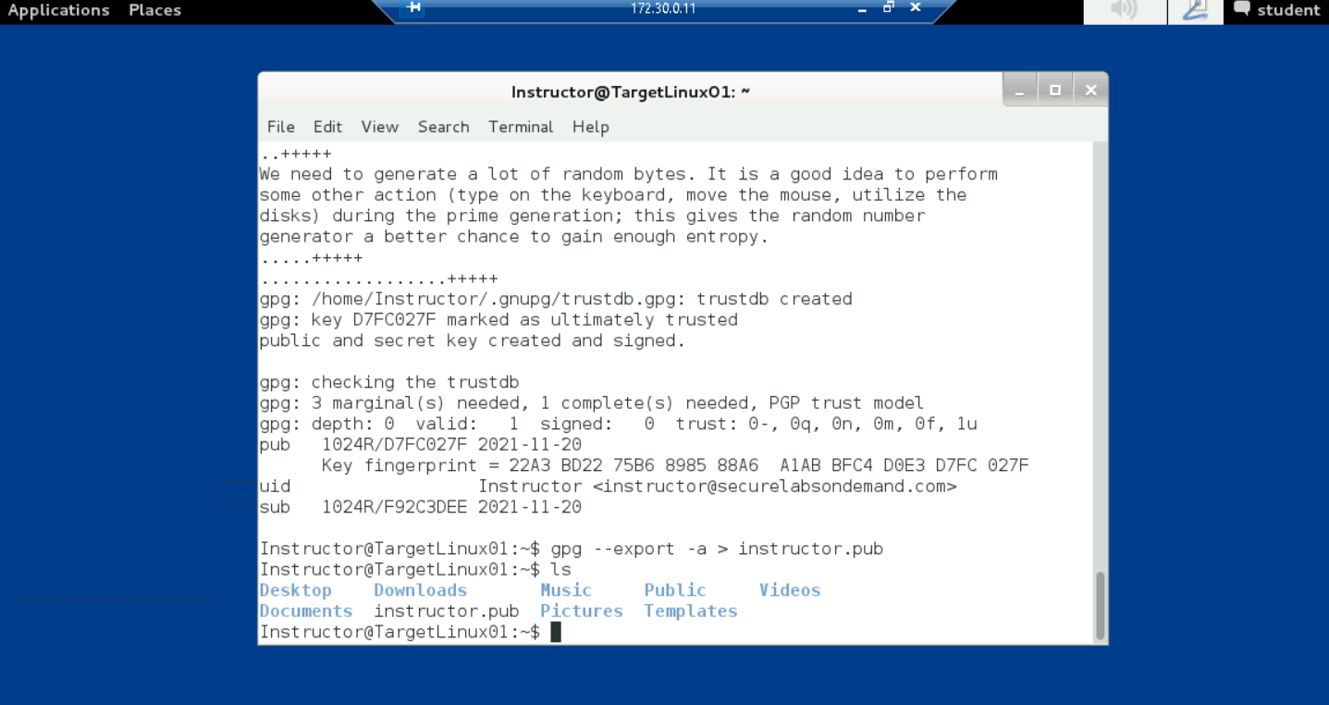

At the command prompt, type exit and press Enter to return to using the student account

The command prompt should change to student@TargetLinux01:~/Documents$

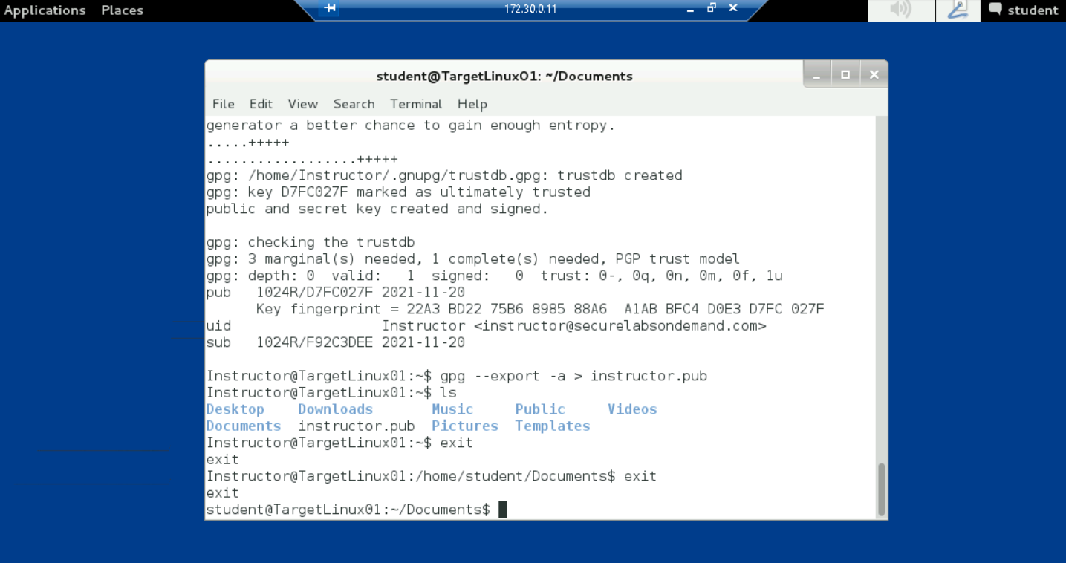

Part 5: Share a GnuPG Key

At the command prompt, type cp /home/Instructor/instructor.pub /home/student/Documents/instructor.pub and press Enter to copy the instructor GnuPG keys (instructor.pub) to the student’s Documents folder

At the command prompt, type ls and press Enter to list the contents of the student folder and verify that the instructor.pub file is now included

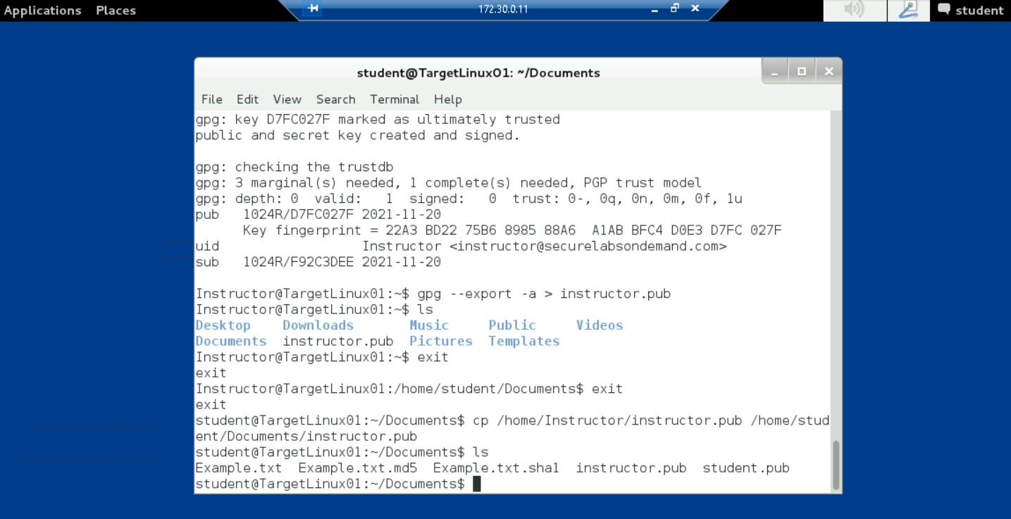

At the command prompt, type gpg --list-keys and press Enter to list the current public key ring for the student account

The key ring will show only the student.pub key. In the next step, you will import the instructor’s public key

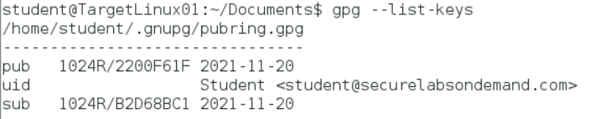

At the command prompt, type gpg --import instructor.pub and press Enter to import the instructor’s GnuPG keys to the student public key ring

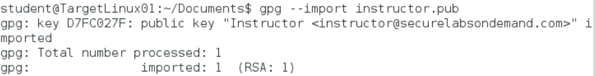

At the command prompt, type gpg --list-keys and press Enter to list the updated public key ring for the student account

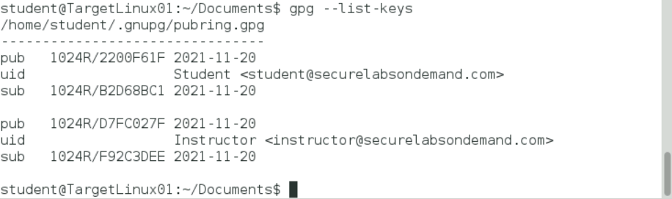

Part 6: Encrypt and Decrypt a ClearText Message

At the command prompt, type gpg --help and press Enter to open the gpg help document, then review the process and options for this tool

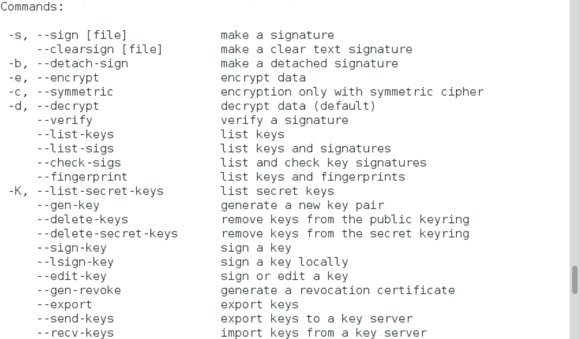

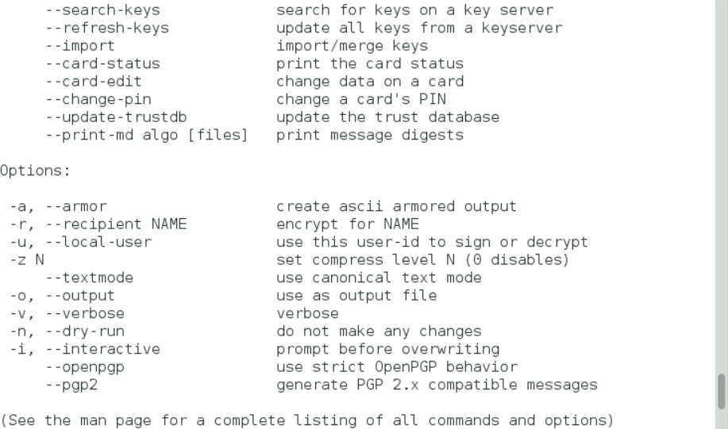

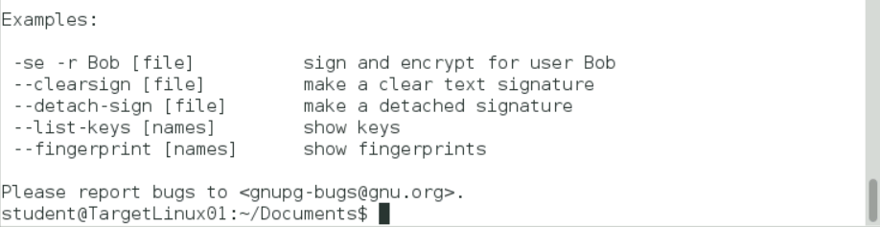

At the command prompt, type echo “this is a clear-text message from yourname” > cleartext.txt, replacing yourname with your own name, and press Enter to save a clear-text message to a new file named cleartext.txt

At the command prompt, type cat cleartext.txt and press Enter to view the contents of the new file

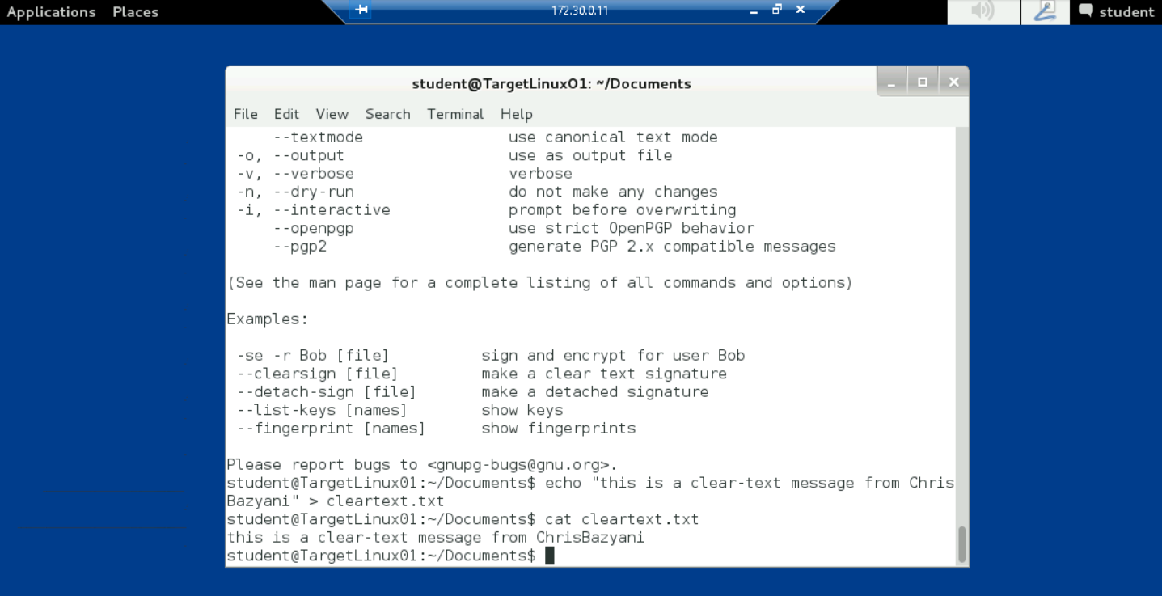

At the command prompt type gpg -e cleartext.txt and press Enter to encrypt the file. The GnuPG -e switch is used to encrypt data; GnuPG -d is used to decrypt data. You will decrypt this file later in the lab

When prompted by the encryption process, type the following responses. Press Enter after each entry

Enter the [recipient] user ID. End with an empty line: Instructor

Use this key anyway? (y/N): y

Enter the user ID. End with an empty line: press Enter

At the command prompt type ls and press Enter to list the contents of the folder and verify that the encrypted file (cleartext.txt.gpg) has been created

At the command prompt type cat cleartext.txt.gpg and press Enter to view the contents of the file and verify that it is encrypted

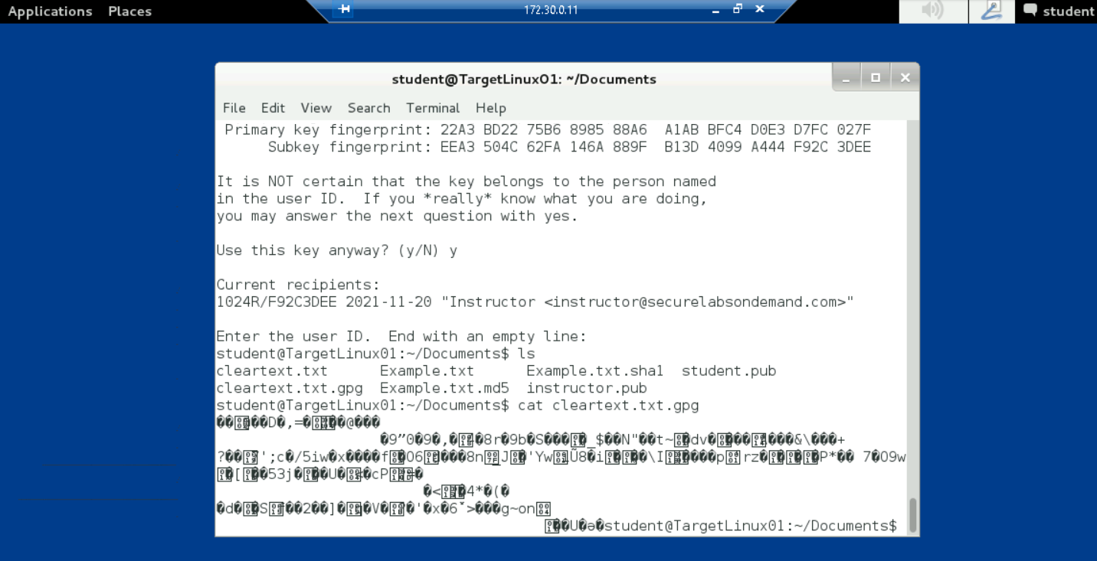

Note: In the next steps, you will copy the cleartext.gpg message to the Instructor account and use the GnuPG keys you’ve already exchanged to decrypt the cleartext.txt message

At the command prompt, type sudo cp cleartext.txt.gpg /home/Instructor and press Enter to copy the cleartext.txt.gpg file to the instructor home directory

When prompted for the [sudo] password, type student and press Enter to continue

At the command prompt, type cd /home/Instructor and press Enter to change to the instructor home directory

At the command prompt, type sudo chown Instructor:Instructor cleartext.txt.gpg and press Enter to modify the permissions (change the ownership) of the cleartext.txt.gpg file so the instructor user can open the file

If prompted for the [sudo] password, type instructor and press Enter to continue

At the command prompt, type ls -la and press Enter to list the contents of the instructor folder and the file permissions associated with each file

Verify that the instructor has read privileges to the cleartext.txt.gpg file

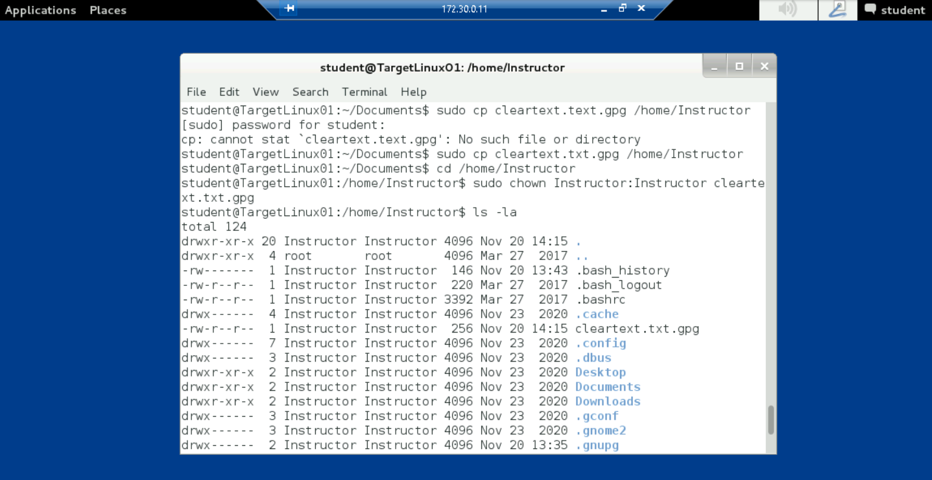

At the command prompt, type su Instructor and press Enter to switch to the Instructor account

When prompted for a password, type instructor and press Enter. The command prompt should change to instructor@TargetLinux01:~$

At the command prompt, type gpg -d cleartext.txt.gpg and press Enter to decrypt the message

When prompted for the GnuPG passphrase, type today is a nice day and press Enter. The system will display the contents of the decrypted message

Make a screen capture showing the contents of the decrypted cleartext.txt.gpg file and paste it into your Lab Report file

At the command prompt, type exit and press Enter to return to the student account

At the command prompt, type exit and press Enter to close the command prompt window

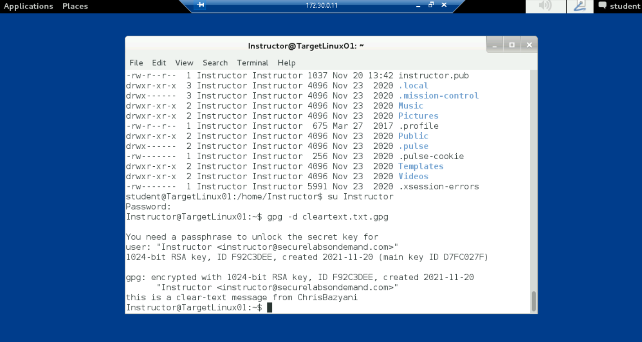

**Section 2: Applied Learning**

Part 1: Create a Text File on Linux

From the Connections folder, double-click the TargetLinux01_CMD shortcut to open a PuTTY connection to the TargetLinux01 machine using the student account. The command prompt should display as student@TargetLinux01:~$

At the command prompt, execute whoami to verify the logged in user account is the student

At the command prompt, execute the command to change the working directory to the student’s Documents folder

At the command prompt, execute vi Example2.txt to create a new file using the vi Editor

In the vi Editor, type i to enter edit mode, then add the following text, replacing yourname with your own name. This file is from yourname

In the vi Editor, press Esc to exit edit mode, then type :wq! and press Enter to save your changes and return to the command prompt

At the command prompt, execute cat Example2.txt to display the contents of the Example2.txt file

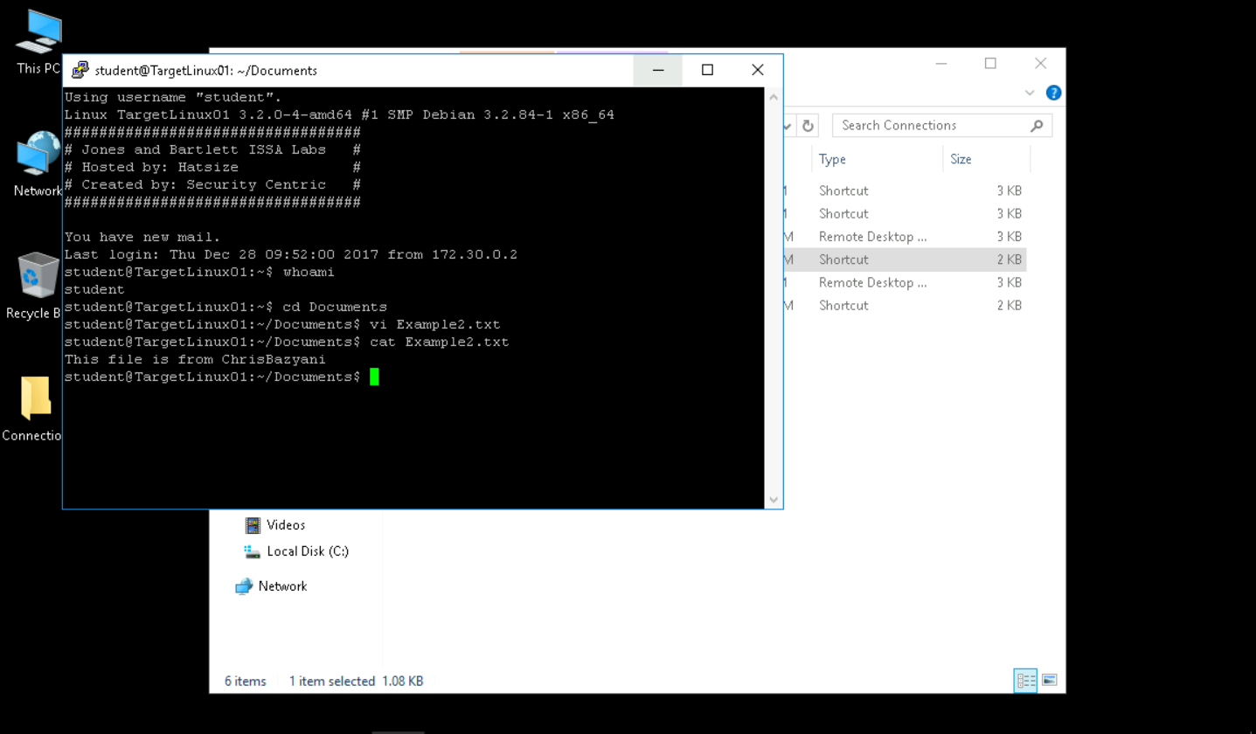

Part 2: Create a MD5sum and a SHA256sum hash string

At the command prompt, execute md5sum --help to open the md5 help document, then review the process and options for this tool

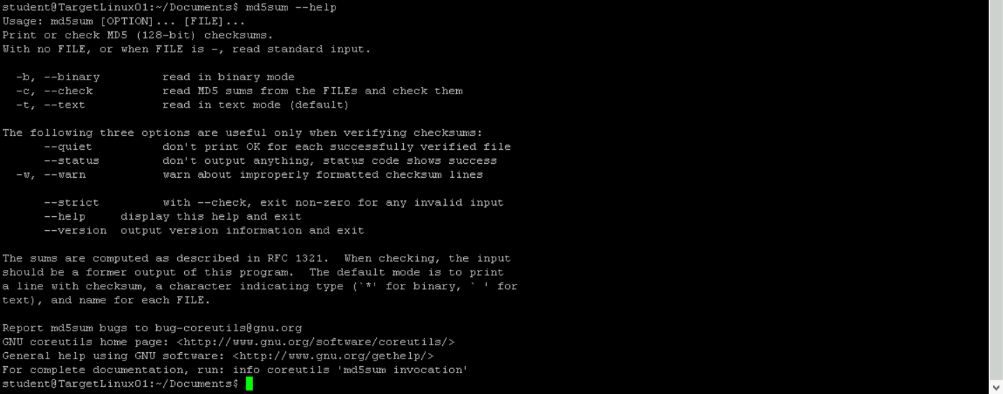

At the command prompt, execute md5sum Example2.txt to create an MD5sum hash string for the Example2.txt file

The tool will return a string of hexadecimal numbers



At the command prompt, execute md5sum Example2.txt > Example2.txt.md5 to store the MD5sum hash string for the Example2.txt file in a new file



At the command prompt, execute ls to list the files in the Documents folder and verify that the new Example2.txt.md5 file has been saved properly

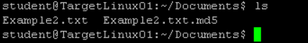

At the command prompt, execute cat Example2.txt.md5 to display the contents of the Example2.txt.md5 file

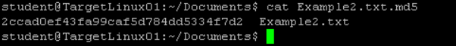

At the command prompt, execute md5sum -c Example2.txt.md5 to check the MD5sum hash created for the Example2.txt file

If the file has not been modified, the system will display the words Example2.txt: OK, indicating that the MD5sum hash is the same for both



At the command prompt, execute the command to open the sha256sum help document, then review the process and options for this tool

At the command prompt, execute the command to create a sha256sum hash string for the Example2.txt file



The tool will return a much longer string of hexadecimal numbers

At the command prompt, execute the command to store the sha256sum hash string for the Example2.txt file in a new file titled Example2.txt.sha256

At the command prompt, execute the command to list the files in the Documents folder and verify that the new Example2.txt.sha256 file has been saved properly

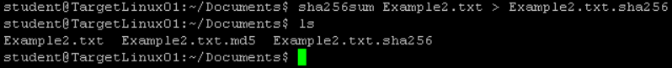

At the command prompt, execute the command to display the contents of the Example2.txt.sha256 file



At the command prompt, execute the command to check the sha256sum hash created for the Example2.txt file



If the file has not been modified, the system will display the words Example2.txt: OK, indicating that the SHA-256sum hash is the same for both

Part 3: Modify a File and Verify Hash Values

At the command prompt, execute echo “This example is testing hash values.” >> Example2.txt to add the words to the end of the Example2.txt file, modifying its contents

At the command prompt, execute the command to display the contents of the modified Example2.txt file

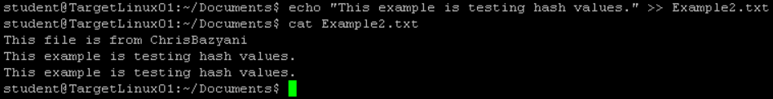

At the command prompt, execute md5sum Example2.txt > Example2.txt.md5 to create an MD5sum hash for the modified Example2.txt file and overwrite the existing Example2.txt.md5 file



At the command prompt, execute the command to create a sha256sum hash for the modified Example2.txt file and overwrite the existing Example2.txt.sha256 file



At the command prompt, execute the command to display the contents of the modified Example2.txt.md5 file



At the command prompt, execute the command to display the contents of the modfied Example2.txt.sha256 file



Part 4: Generate GnuPG Keys

In the terminal window, verify that the command prompt is student@TargetLinux01:~/Documents$, indicating that student is the logged on user

At the command prompt, execute gpg --gen-key to generate a public encryption key

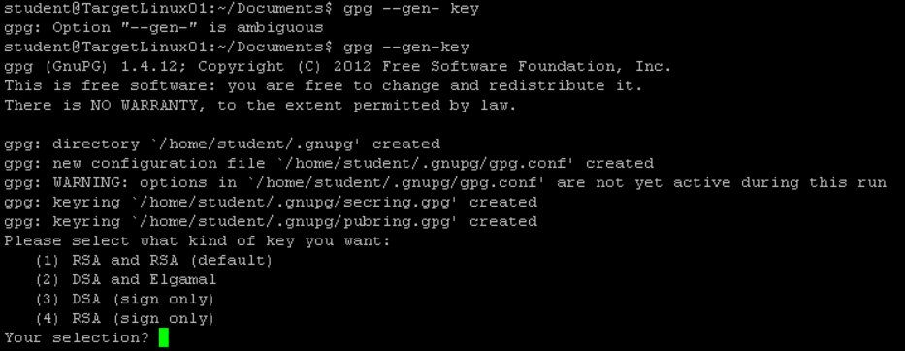

When prompted by the key generator, type the following answers in response to the onscreen questions. Press Enter after each entry

Your [key type] selection? 1 (RSA and RSA default)

What keysize do you want? 2048 (2048 bit length)

Key is valid for? 0 (Key does not expire at all)

Is this correct? y (yes)

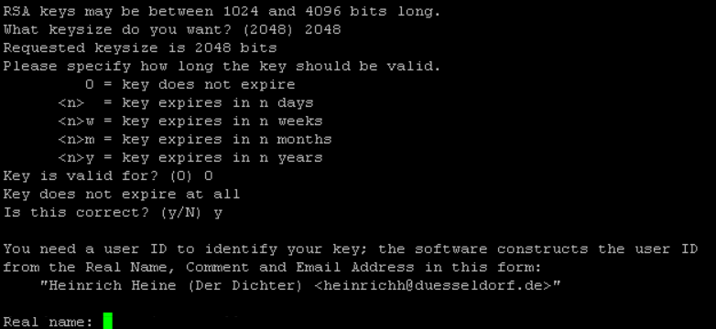

When prompted by the key generator, type the following answers in response to the request for a user ID to identify your key. Press Enter after each entry

Real name: Student2

Email address: student@securelabsondemand.com

Comment: press Enter Change (N)ame, (C)omment, (E)mail or (O)kay/(Q)uit?: O

Passphrase: encryption key

Repeat passphrase: encryption key

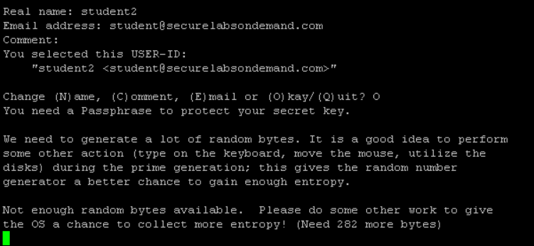

From the Connections folder, open a new TargetLinux01_CMD PuTTY connection

In the new PuTTY window, execute ./entropy_loop.sh to generate entropy for the key generation process

Resize the open windows so that all windows are visible and the remote command prompt window is on top

Note: How many bytes are sufficient to generate a GnuPG key pair? It’s anyone’s guess and it’s different each time the key is generated. In this lab, the process may sometimes take up to 10 minutes. The command you enter in step 6 merely lists files in an attempt to “keep the machine busy”

When the command prompt returns, close the second PuTTY connection, leaving only the original PuTTY window open

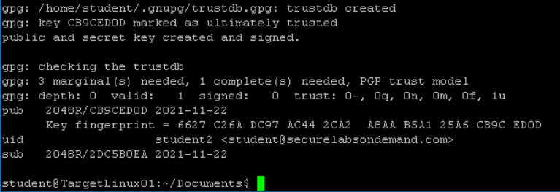

In the PuTTY window, execute gpg --export –a > student2.pub to save the new GnuPG key to a student2.pub file

At the command prompt, execute gpg --list-keys to list the student's public key ring

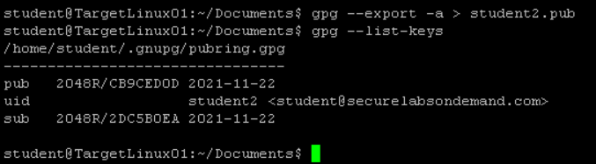

Minimize the TargetLinux01 PuTTY connection

From the Connections folder, double-click the TargetLinux02_CMD shortcut to open a PuTTY session to the TargetLinux02 machine using the Instructor account

The command prompt should display as Instructor@TargetLinux02:~$

At the command prompt, execute the command to verify the logged in user account is the instructor

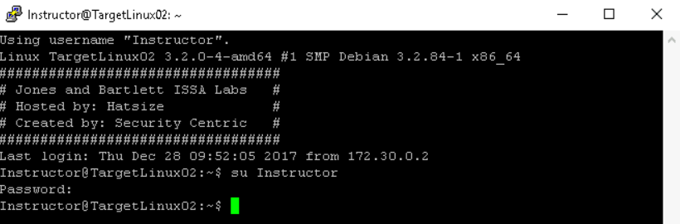

Repeat steps 2-8 to create the GnuPG keys for the Instructor account on TargetLinux02. Note the following changes to steps 4 and 5

Real name: Instructor2

Email address: instructor@securelabsondemand.com

PuTTY connection: TargetLinux02_CMD

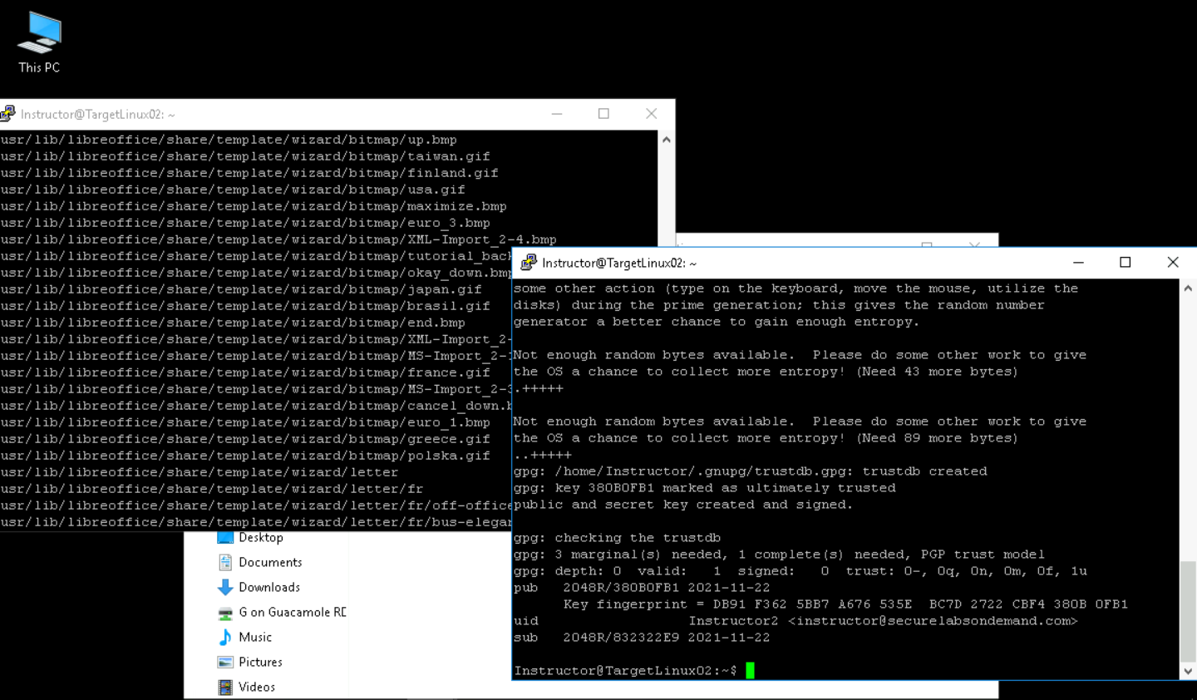

At the command prompt, execute gpg --export –a > instructor2.pub to save the new GnuPG key to a new file called instructor2.pub

At the command prompt, execute the command to list the keys in the instructor’s public key ring

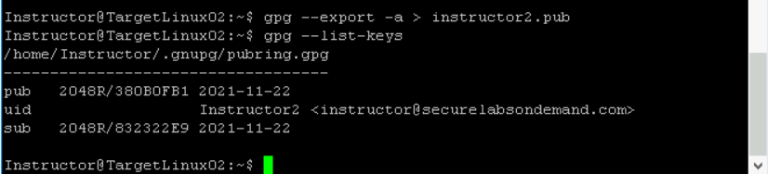

Part 5: Share a GnuPG Key

From the Connections folder, double-click the KeyTransfer12 shortcut to open a WinSCP connection to the TargetLinux02 machine

In the KeyTransfer window, drag the instructor2.pub file from the right pane (/home/Instructor) to the left pane to copy the file to the vWorkstation (C:\Users\Administrators\Documents), then close the window

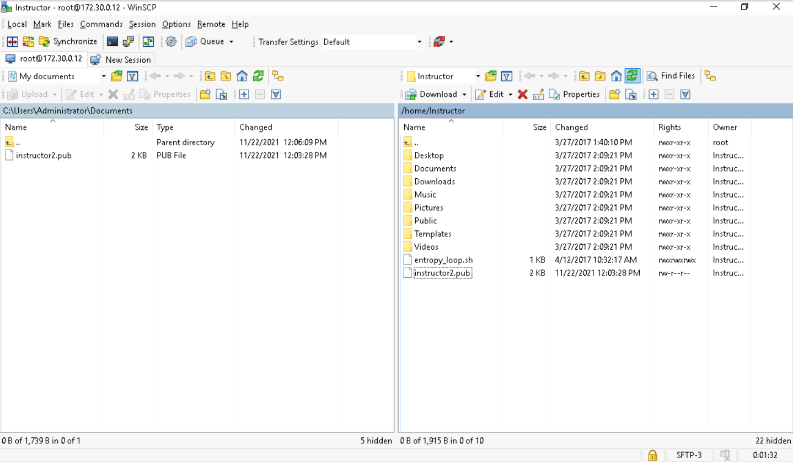

From the Connections folder, double-click the KeyTransfer11 shortcut to open a WinSCP connection to the TargetLinux01 machine

In the KeyTransfer window, copy the instructor2.pub file from the vWorkstation to TargetLinux01 (/home/student/Documents)

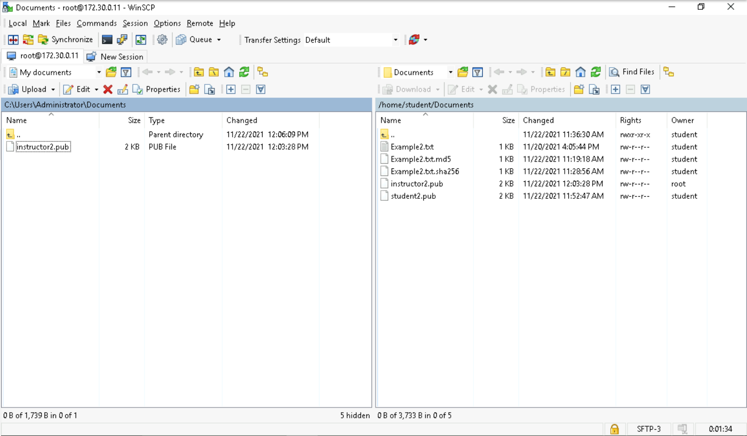

In the right pane, right-click the instructor2.pub file and select Properties to change permissions for this file

In the Properties dialog box, select student [1000] from the Group and Owner menus to make the student the owner of this file

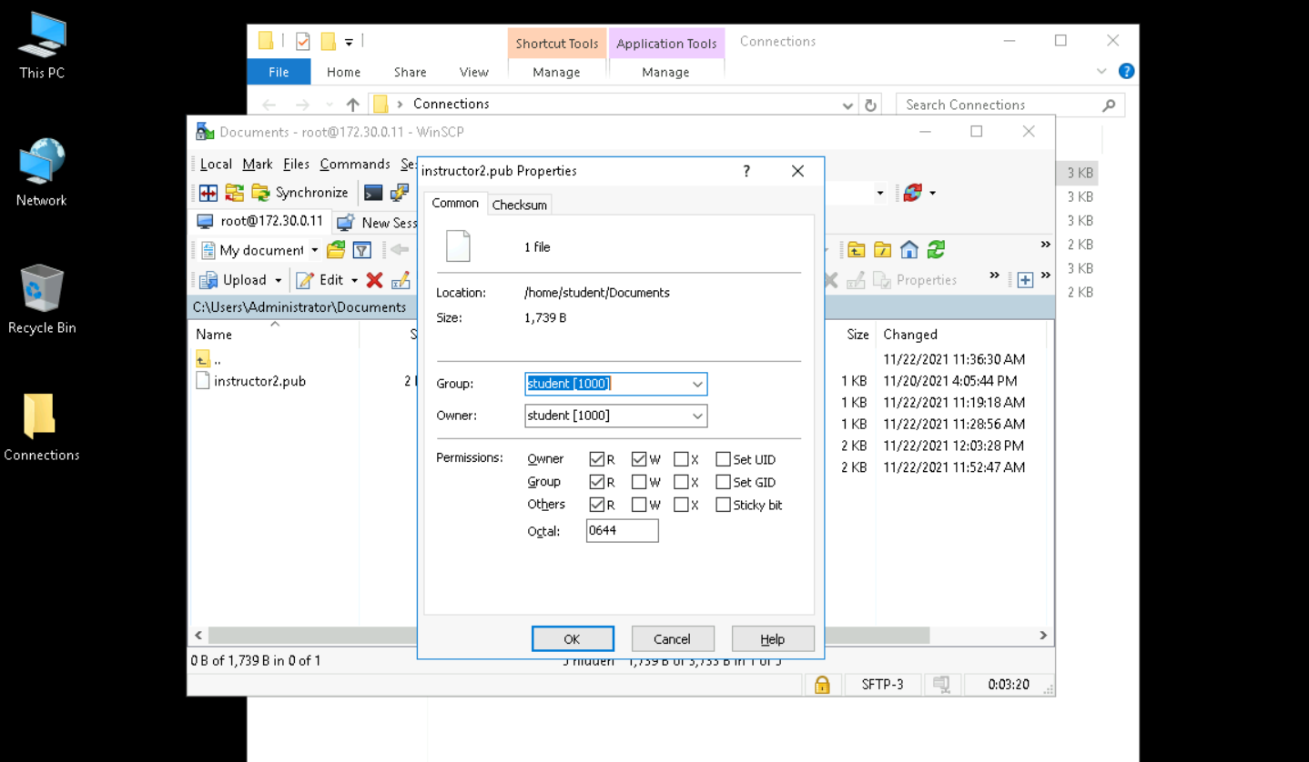

At the command prompt, execute ls -l to list the contents of the Documents folder and verify that the instructor2.pub file is now included

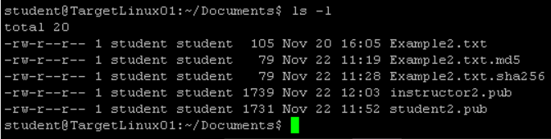

At the command prompt, execute gpg --import instructor2.pub to import the instructor’s GnuPG keys to the student public key ring

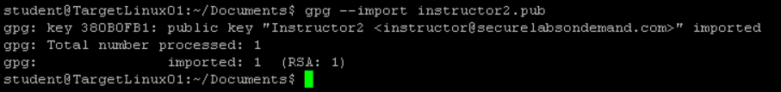

At the command prompt, execute the command to list the updated public key ring for the student account

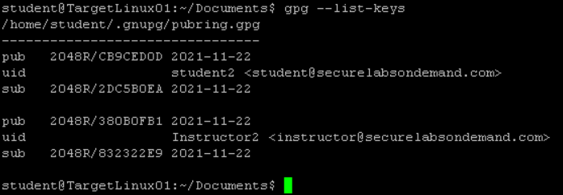

Part 6: Encrypt and Decrypt a ClearText Message

At the command prompt, execute the command to open the gpg help document, then review the process and options for this tool

At the command prompt, execute echo “This clear-text message is from yourname” > cleartext2.txt, replacing yourname with your own name, to save a clear-text message to a new file named cleartext2.txt

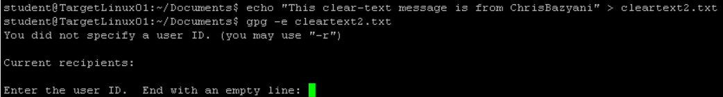

At the command prompt, execute the command to display the contents of the cleartext2.txt file

At the command prompt, execute gpg -e cleartext2.txt to encrypt the file

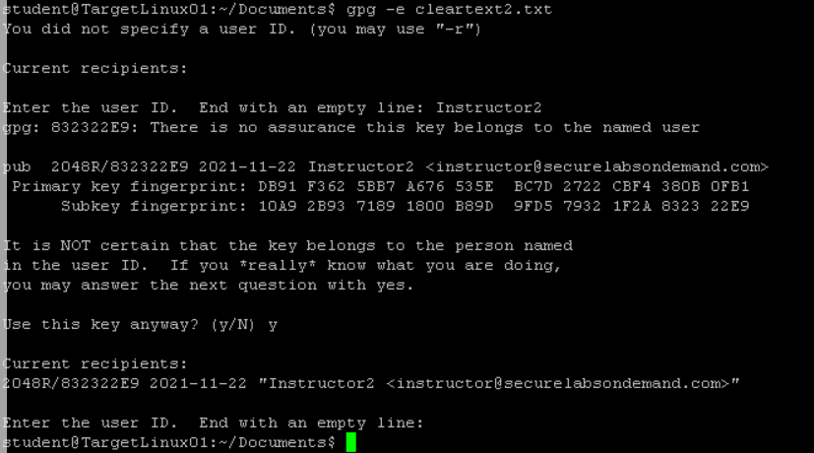

The GnuPG -e switch is used to encrypt data; GnuPG -d is used to decrypt data. You will decrypt this file later in the lab

When prompted by the encryption process, type the following responses. Press Enter after each entry

Enter the [recipient] user ID. End with an empty line: Instructor2

Use this key anyway? (y/N): y

Enter the user ID. End with an empty line: press Enter

At the command prompt, execute the command to list the contents of the folder and verify that the encrypted file (cleartext2.txt.gpg) has been created



At the command prompt, execute the command to display the contents of the cleartext2.txt.gpg file and verify that it is encrypted

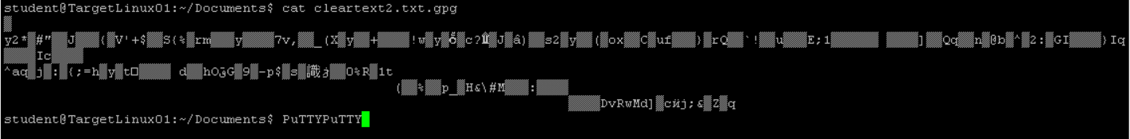

Minimize the TargetLinux01 PuTTY window

From the Connections folder, double-click the KeyTransfer11 shortcut to open a WinSCP connection to the TargetLinux01 machine

In the WinSCP window, copy the cleartext2.txt.gpg file from the TargetLinux01 machine (/home/student/Documents) to the vWorkstation, then close the WinSCP window

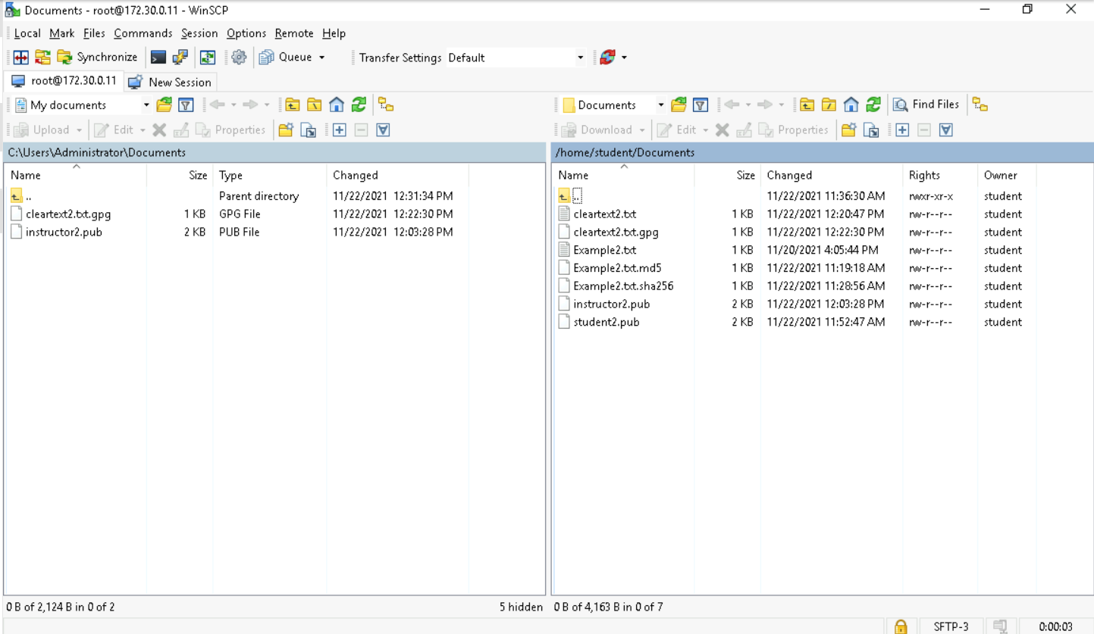

From the Connections folder, double-click the KeyTransfer12 shortcut to open a WinSCP connection to the TargetLinux02 machine

In the WinSCP window, copy the cleartext2.txt.gpg file from the vWorkstation to the TargetLinux02 machine

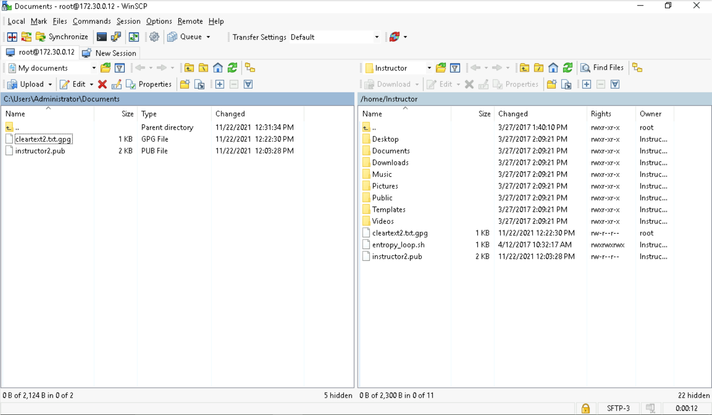

In the right pane, right-click the cleartext2.txt.gpg file and select Properties to change permissions for this file

In the Properties dialog box, select Instructor [1001] from the Group and Owner menus to make the instructor the owner of this file

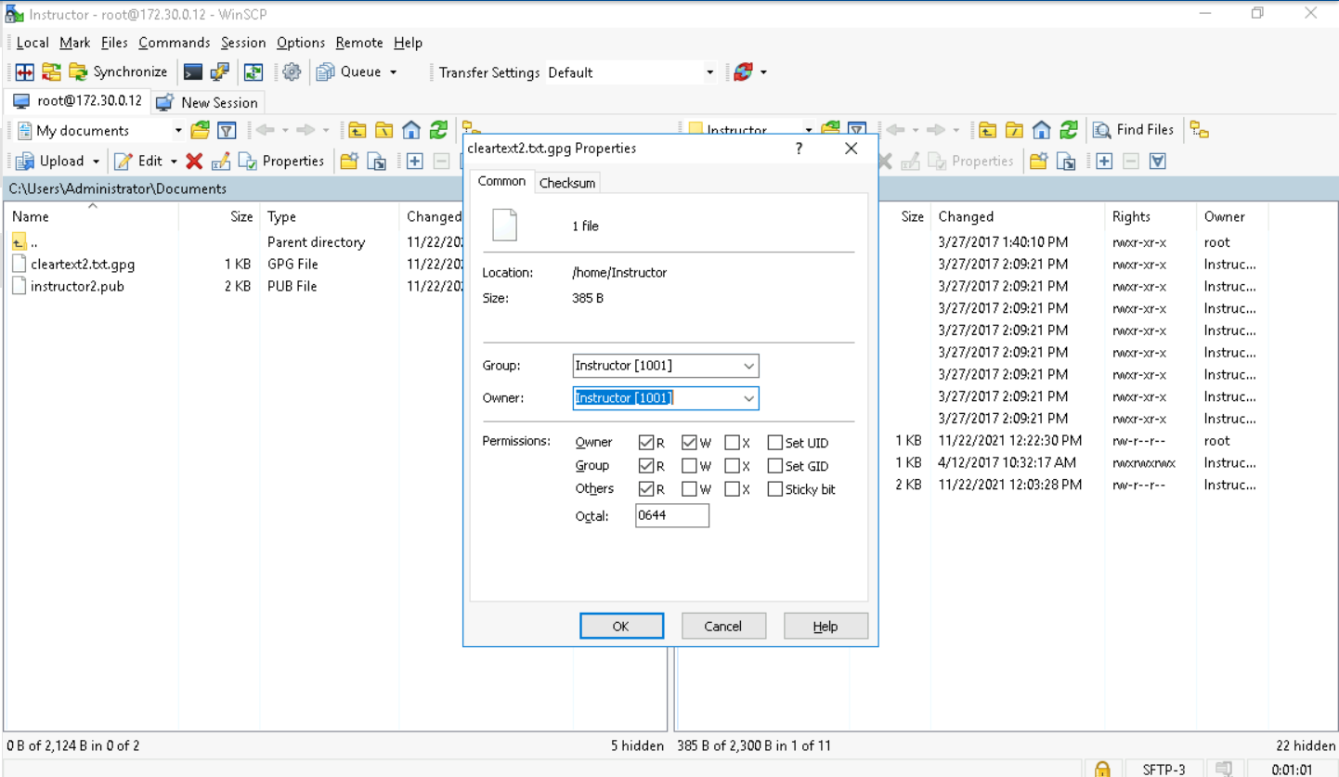

Click OK to close the Properties dialog box, then close the WinSCP window

Restore the TargetLinux02 PuTTY connection

At the command prompt, execute gpg -d cleartext2.txt.gpg to decrypt the file and return it to a clear text human-readable format

When prompted, type the passphrase used to create the encryption certificate

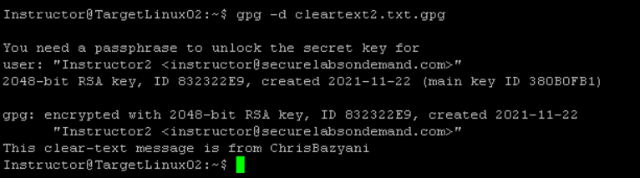

Close any open window